**Sprint 1**

**Home Page**

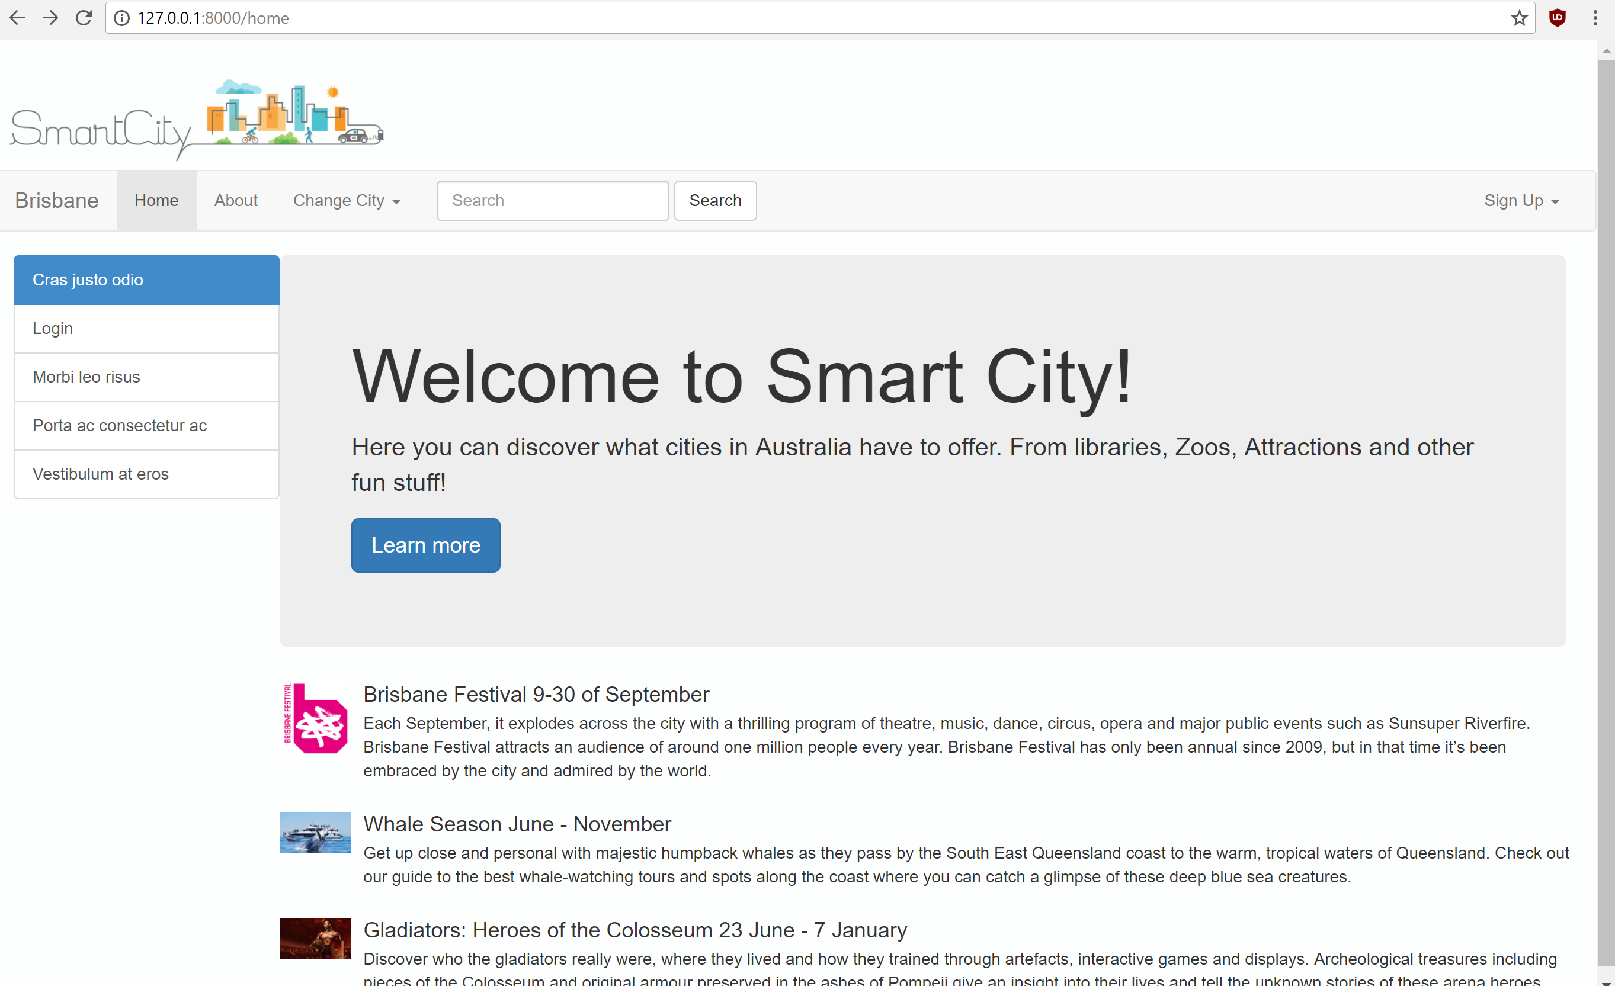

Doesn’t look professional

Not pleasant for eyes.

Poor formatting

Poor colour scheme

Different Fonts and sizing.

**Critique:** Messy, too many colours, not cohesive. The different colours, not comely look of the site can affect the stay time of a new user, and if they want to register an account. Ugly looking front end, indicates a dodgy, unprofessional site that most will not want to use. The grey and white are too similar and make some important features of the site, unseeable in comparison to the bold strong test in the middle. The navigation bar should be on all pages, and be a stronger colour. The recent news is a nice touch, but it is hard coded into the html files, and cannot be edited by admin users, only developers. Add this to admin control.

**User Home (Student)**

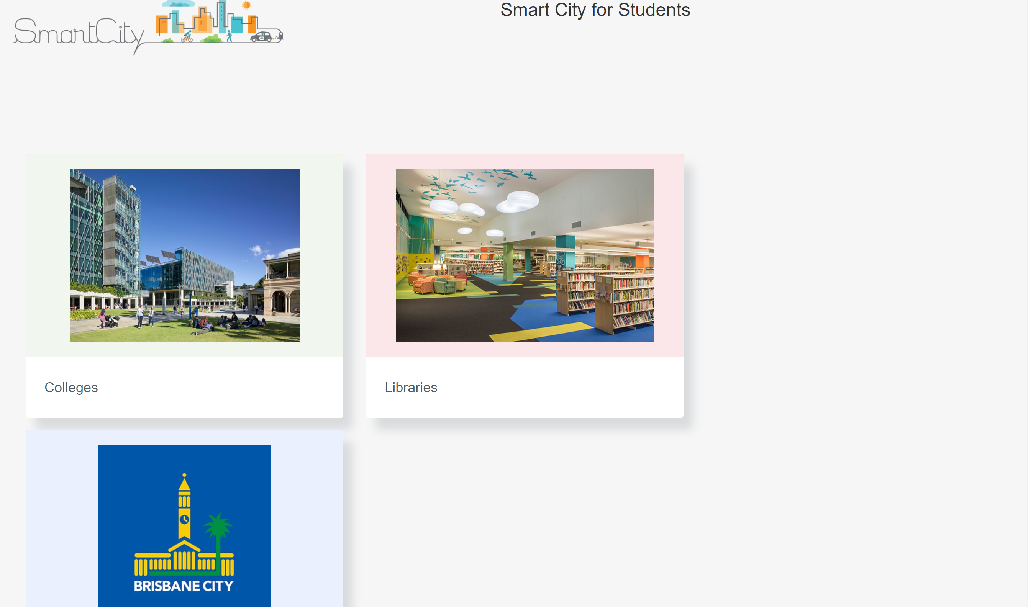

Boring. Poor font.

No navigation bar or logout.

Gap? Could fit this other tile.

**Critique:** Upon logging on the user will see this. The navigation bar is gone, no logout button, and the tile selection has room on the right side, but is placed underneath instead. The tile are now uncentered. The colour palette is like chalk, and does not fit well with the light grey scheme. The title indicating the smart city for students is also plain and uninteresting.

**City Selection**

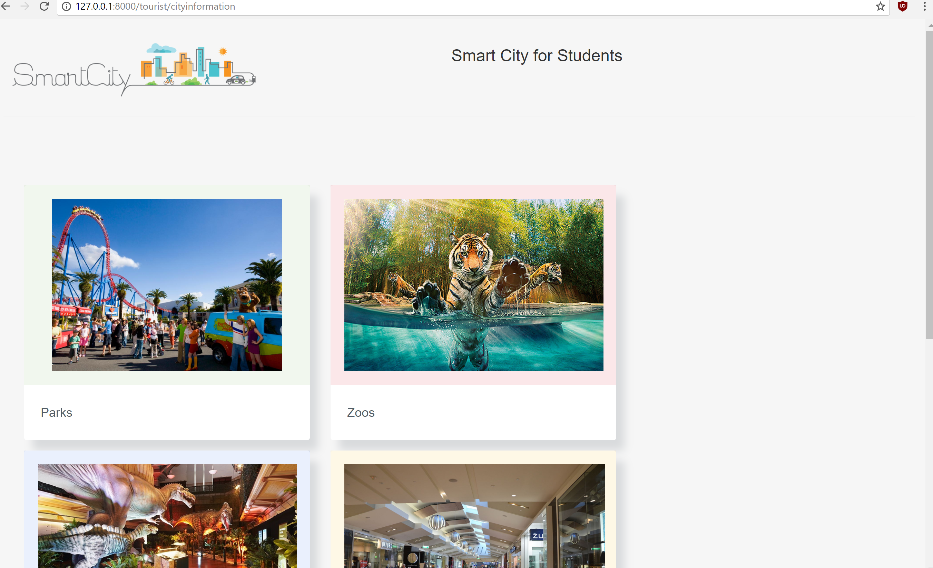

No nav bar or logout!

Gap again!

**Critique:** This page flows well from the last page, but the colour palette is still just as poor. There is still room for tiles to be placed on the right side, instead of a new line, and makes the site look uneven and unprofessional. A navigation bar on the page is also unseen.

**General Feedback for Sprint 1 Website:**

The website is a good start, with working functionality, however front end interface wise, it is rather not pretty and can do with an upgrade to please users and client. Nicer looking sites will increase user interest and time, for them to register an account. The flow of the website is poor, with a navigation bar on only one, and a completely different colour scheme in the following pages.

**Sprint 2**

**Home Page**

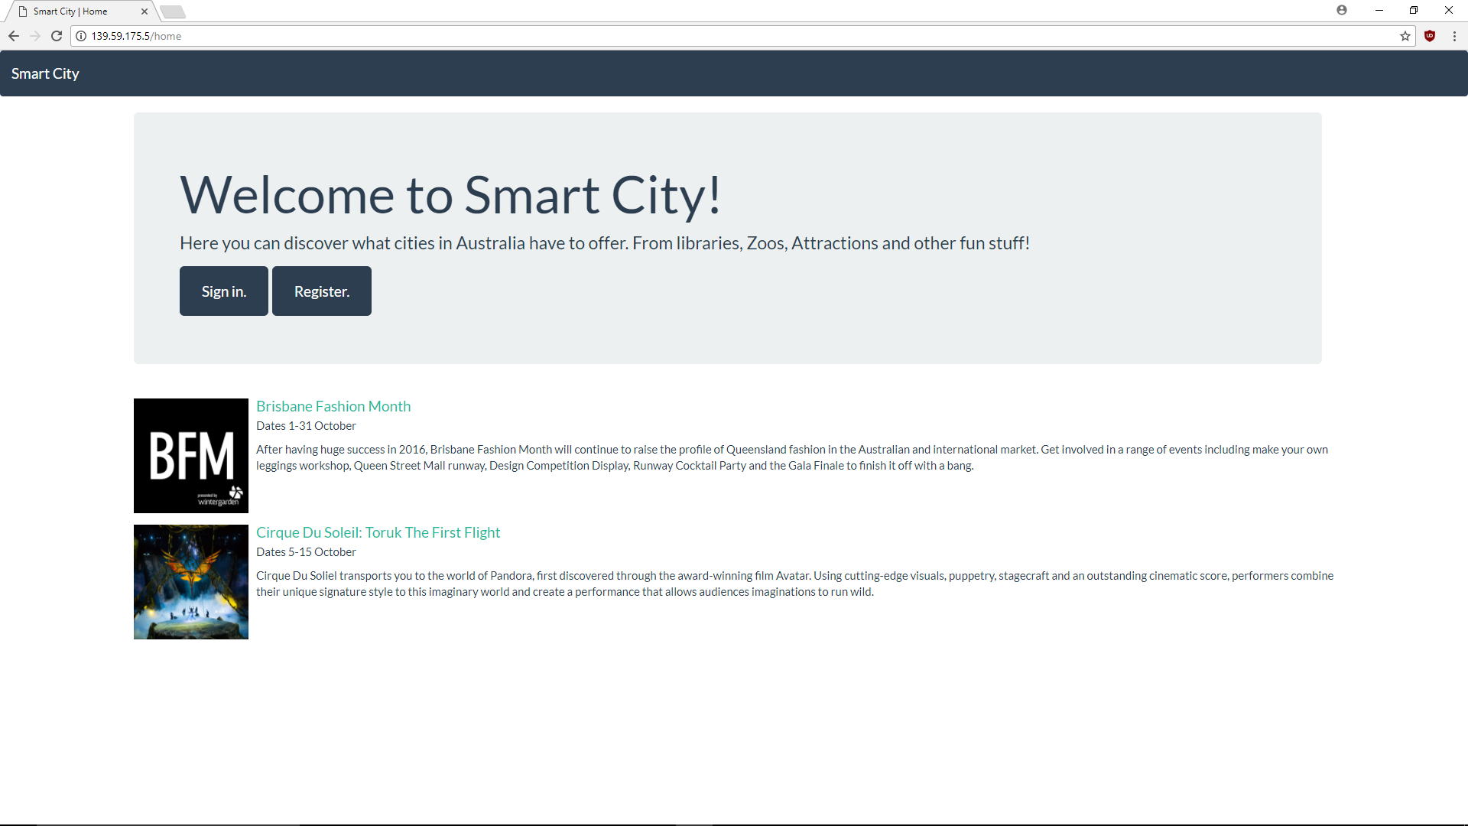

Nicer recent news feed, link to event. Events now managed by admins.

Nice and very visible Sign in/Register Buttons

Improved Navigation Bar, more stand out colour, simplistic

**Critique:** Home page, the first page users see, looks very welcome and professional. The site is easy to look at, with a easily locatable sign in and register buttons. The colour scheme is a huge improvement, with the navy/grey on white/grey looking pleasant and not too distracting. The news feed is even nicer, as a result of the font overhaul, and now managed by admin users to update events more recently, rather than developers. The sprint 2 home page is a huge improvement from the sprint 1 home page.

**Login**

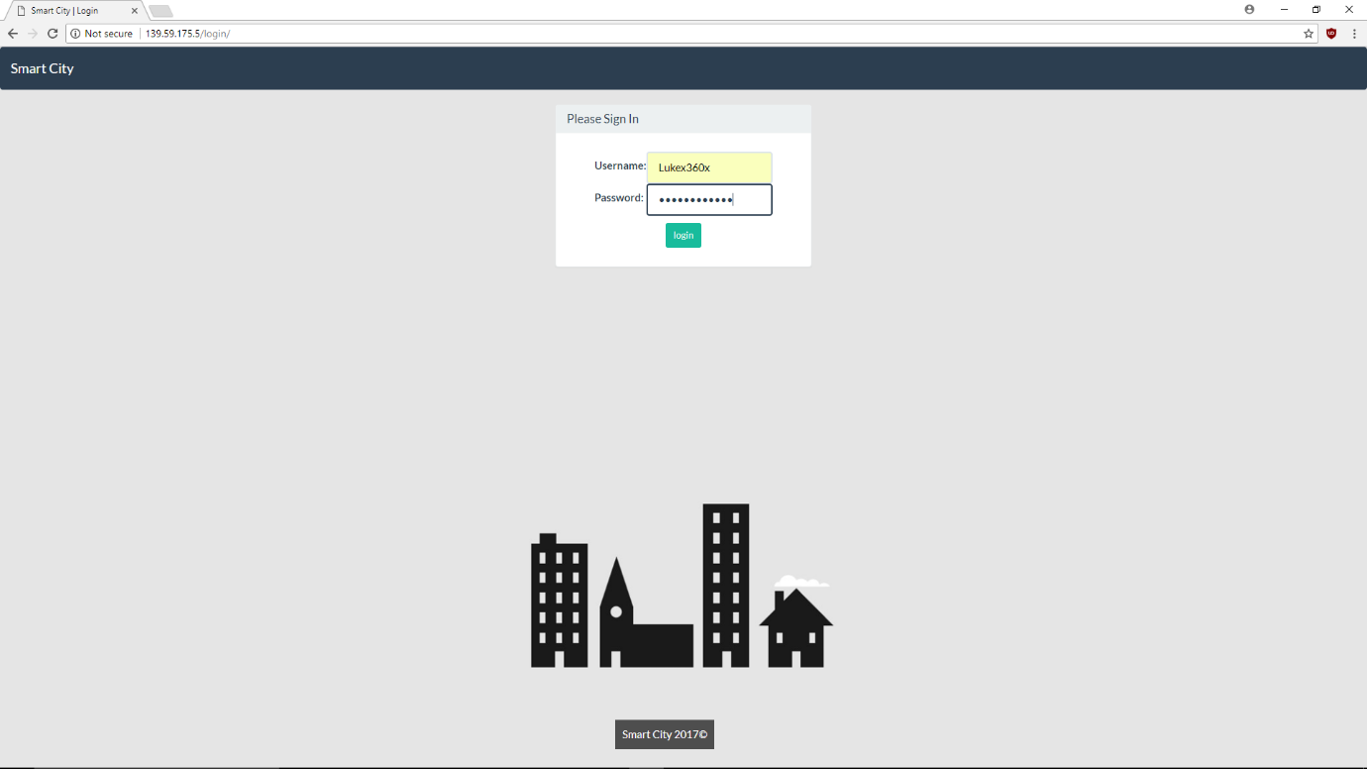

**User Home (Student)**

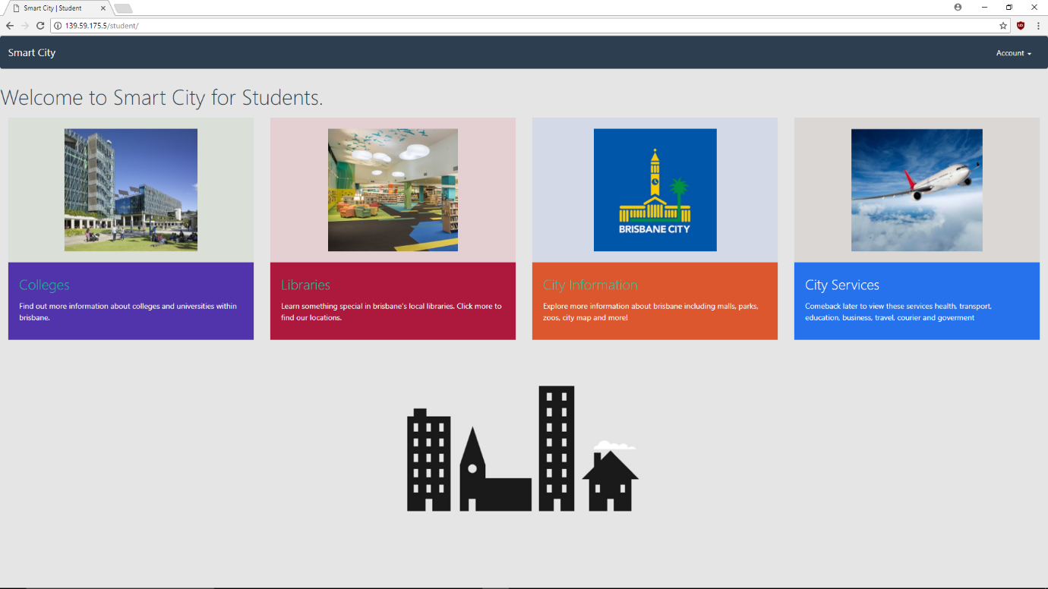

**Critique:**

Upon logging on the user will see this. The colour scheme has received a huge improvement from the boring chalk, to now vibrant windows metro colours. The tiles are now all centred an waste no room on the page, compared to the poor formatting of the first site. The font overhaul makes the site look a lot less busy than the previous page. The wallpaper, continuing from the homepage is a nice touch, remove the imbalance of empty space below and provides nice cohesion amongst webpages. The navigation bar is also continued on this page, and adds an account option for logging out, as well as home page, selecting cities, contact page and FAQ for quick access.

**City Information**

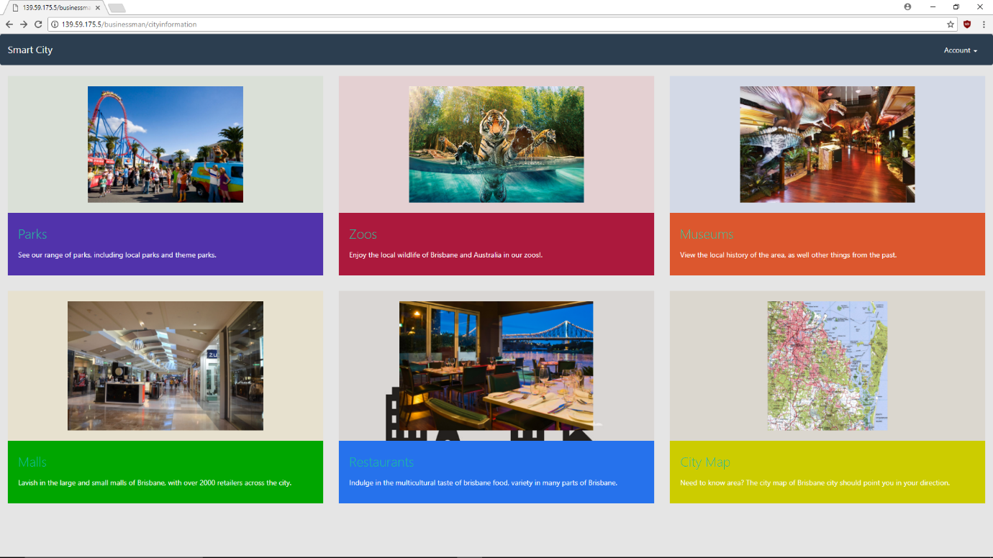

**Critique:** The colour palette here is extremely nice for the eyes, adding colour to the simple colour scheme before, for users to distinguish the different information libraries to choose from. It is very comely, and the tiles are all neatly centred and waste no room. It is geometrically pleasing. The navigation bar flows nicely on this page as well.

**General Feedback for Sprint 2 Website:**

The website overhaul for the GUI front end was exceptional for an improvement, with formatting layout issues, different fonts and sizes, poor colour scheme, bad page cohesion and missing navigation bars were all fixed. The navy/grey and white/grey is a really appealing colour scheme, with eccentric metro colours for important library tiles to direct the users attention accordingly. The navigation bar flows nicely on all pages, and allows for a dropdown menu, including logout, after authentication. The overhaul makes the site look very professional and will please both users, the client as well as us developers. This colour scheme, font, layout, navigation bar should be used for the creation of all webpages on the site, including future html pages being added.